EAST SCHOOL
815 E. 13th Street
Des Moines, IA 50316
Telephone 515-242-7788 Fax 515-242-7958

LESLIE MORRIS, PRINCIPAL CHAD STREET, VICE PRINCIPAL
KELLI RIXNER, SCHOOL IMPROVEMENT LEADER STEVE SCHAPPAUGH, SCHOOL IMPROVEMENT LEADER
JILL VERSTEEG, SCHOOL IMPROVEMENT LEADER JOSEPH SPIESS, SCHOOL IMPROVEMENT LEADER

Dear East Families,

We would like to invite you to join us for fall conferences Wednesday, October 3, 4:15-7:30pm. We also would like to inform you of updates to our grading practices. These changes were made in an effort to motivate students to focus less on scoring, and more on their learning.

Adjustments:
- The topic score will be posted at the end of a unit. Be sure to click on the topic to see your student’s progress. The 9-week marking period is just a snapshot of your student’s learning. Their growth will continue to be monitored throughout the semester.
- You may see the following acronyms on Infinite Campus:
  - ET: Exceeding Target (3.5-4)
  - AT: Achieving Target (3)
  - PT: Progressing Toward Target (1.5-2.5)
  - NM: Not Meeting Target (0 - 1)
Example from Infinite Campus below:
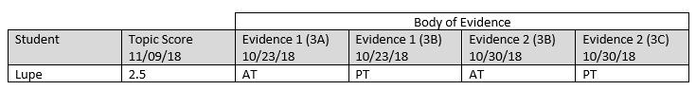
- A student who has earned a D, now has scored between 1.75 – 1.99.
- A score of 0 for one or more topic scores must be given F/IE (Failure/Insufficient Evidence)
- Multiple opportunities will be provided to students. Students will need to take necessary steps to show expanded learning before an additional opportunity can be given.
  - Teachers may limit unit retake opportunities for all but the current unit during the last two weeks of the semester
If you have any questions about these changes, please feel free to visit with teachers during conferences on October 3, 2018, from 4:15-7:30 pm. There will also be two grading practices Q&A sessions at 5:00 and 6:30 in the library.

Respectfully,

East High School

